A1-Analysis:

The Problem

Many teachers try to review for a test in class. However, the best method to do so often eludes them. Some try and quiz the students, some give sample problems, and some play a ‘review game’ that challenges students and brings out their competitive side, while forcing them to remember critical information to win. A common game that I’ve experience over the years is a Jeopardy-type knockoff. It has also been my experience that this works rather well in reviewing because you can ask a broad variety of questions and include a large number of people.

Expanding on this idea, what if there was a way for students to use this format of review to study individually? They could have questions that are specific to a chapter, or perhaps a course review, such as would be good for an AP class before the exam. The potential for student success would greatly increase, and there wouldn’t be a need to have a large group of people to review, nor would valuable class time be taken up to review.

Though it would be intended for individual use, there will also be a ‘multiplayer’ type setting, allowing students to review together and challenge each other. This setting would allow up to two friends to join the user and have a traditional Jeopardy like competition.

In the future, it could be possible to expand beyond just one subject. The program will be compatible to add questions/answers for a broad subject variety, as in the true Jeopardy style.

The program would open with a window to allow the user to select the number of players, as well as a subject, if applicable. They would then be taken to the game screen, which would show the title of the set of questions and a grid of squares, each of which having a question that the user would then answer.

The initial version of this game will include questions to prepare for the AP Computer Science courses. In collaboration with Mr. Jason Parker, the course instructor for our school, he has provided me with a book of sample questions to use for the program. The book, which is a review book that he currently uses, contains both multiple choice sample tests, as well as sample free response questions. This program will only be including multiple choice type questions.

Sample Data

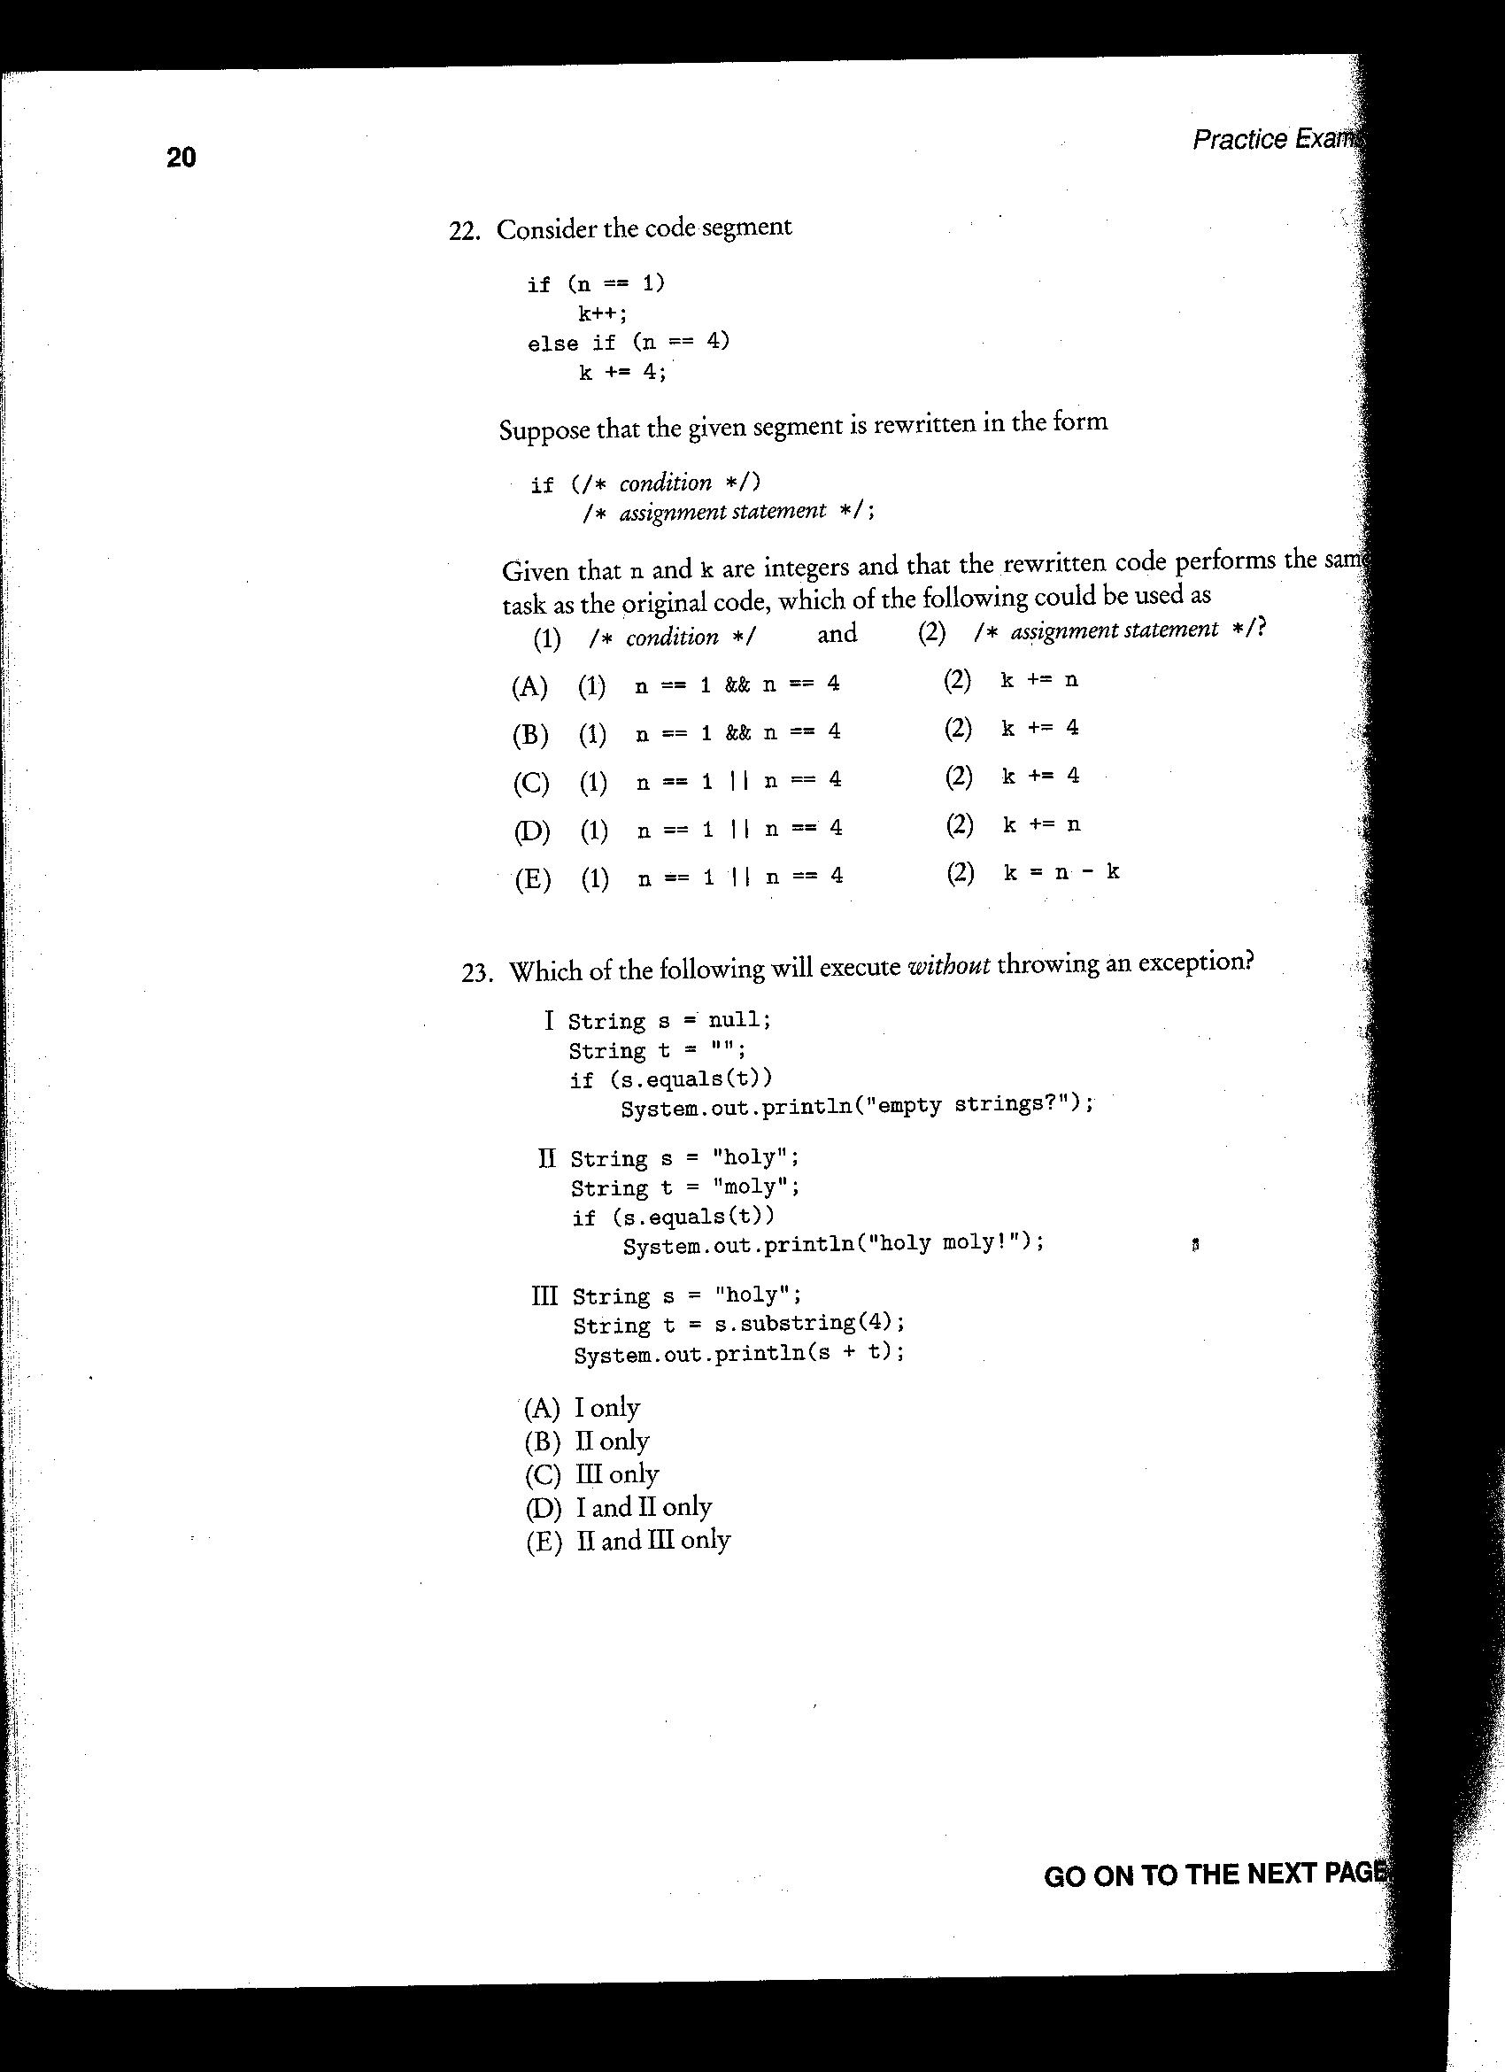
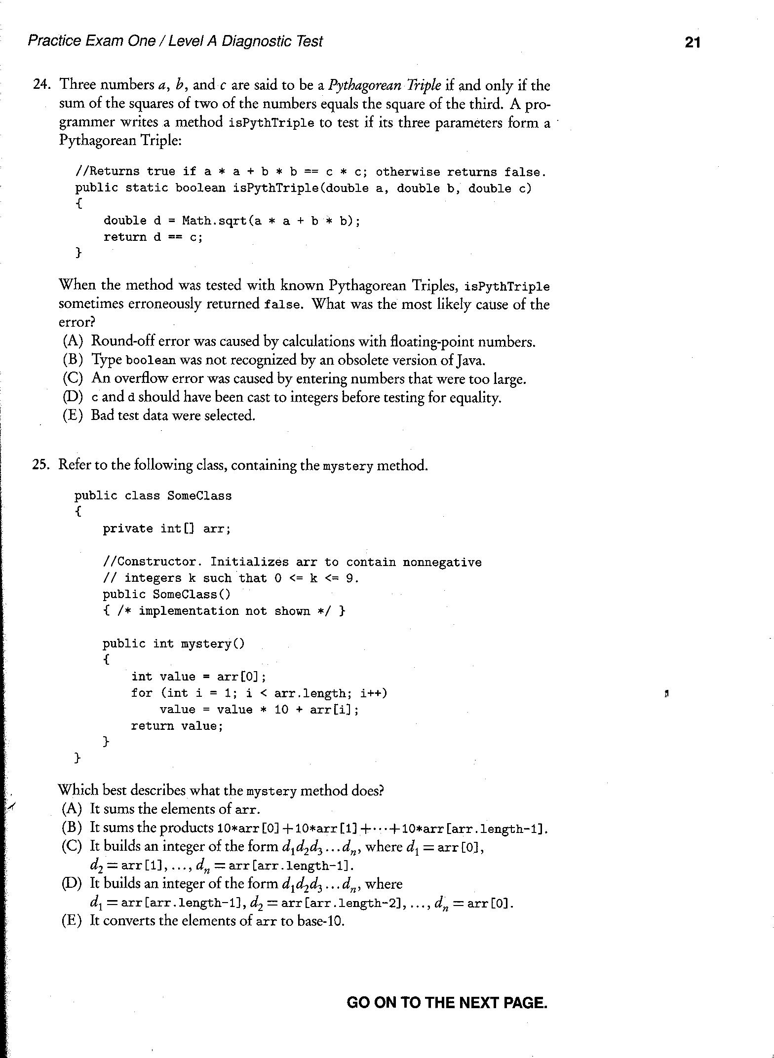
This is how the class currently prepares for tests, by simply taking pre-released tests as well as sample questions prepared by the Barron’s company (pictured above).

A2-Criterion for Success

An easy to use, straightforward interface.
The interface needs to function without much confusion, leaving the user with just the burden of choosing options and entering the answer. If the user cannot easily determine what is required of them and they don’t know how to do what they are supposed to do, then they will simply not use the program.

A smooth random question generator that doesn’t repeat itself continually.
There needs to be minimal repetition in order for the game to be effective. The point of the game is lost if half of the questions are repeated continuously. This will be obtained by selecting the questions at the beginning of the game and they will be set for the remainder of the game. It will be choosing randomly, and after a question is chosen, it’s ‘line index’ will not be available for adding.

Usable by teacher for large scale review by a class.
The game should not be limited to small groups of up to 3 people per game. The teacher should be able to use it in the classroom setting, whether they divide the group into 3 teams, or have an alternate setting for teacher that allows them to specify a number of teams for the game.

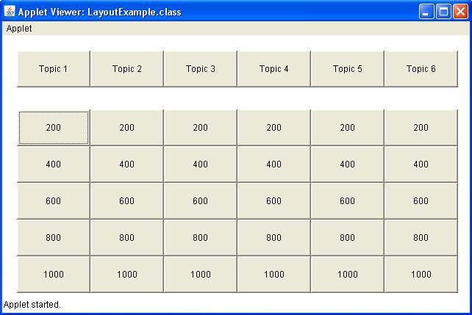
A3-Prototype Solution

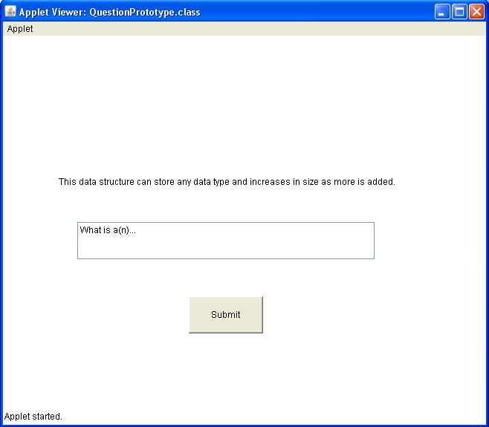
Above is a screenshot of what the question grid will look like when the Prototype is initially loaded. The user will select one of the amounts, much like in the TV game show. After clicking on the amount, the user will be presented with a new window:
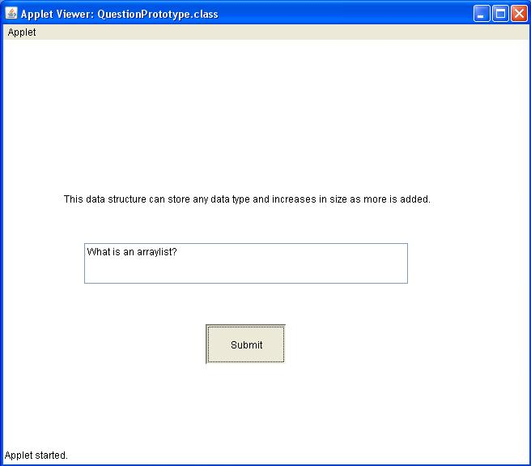
They will then enter their answer in the text field beneath the question. And following that, they would hit the submit button. Critical to getting the question correct, is answering in the correct form. Though not set in stone yet, it will be in the Jeopardy game standard, by answering in question form.
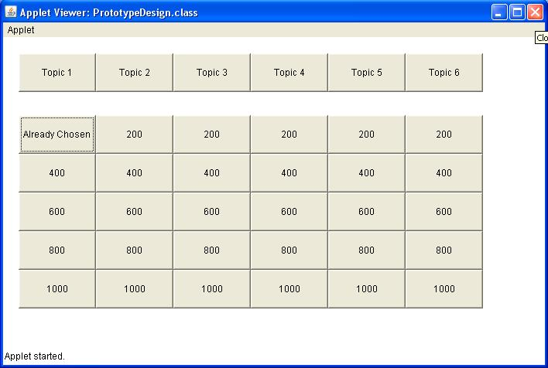
After answering the question, the grid will be updated to reflect that the option has been chosen to prevent repetition issues.

